Files Included
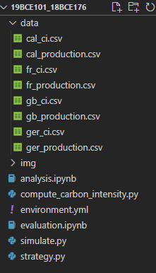
Data Directory:
Contains CSV files of Energy Production and Carbon Intensity datasets for regions like Germany ,Great Britain ,France of Entire Year.

Compute_Carbon_Intensity.py:
It’s a Script used to convert Energy production to Carbon intensity data using energy source provided by IPCC study.

Simulate.py:
Simulates and Evaluates workload shifting approaches in Data Centers with the goal to consume low carbon consumption

Analysis.ipynb:
Used to analyse carbon intensity data.

Evaluation.ipynb:
Used to analyse simulation result.

Environment.yml:
Includes prerequistes for installation and running

Strategy.py:
For workload to shift in both directions it schedules workload in the future.Its basic use is to maintain computation

In Data Directory:
Cal_ci.csv: Contains change in Carbon Intensity relative to every 5 minutes having more than 100000 Records of California.
Similar for France, Great Britain, Germany.

Cal_Production.csv: Initiates the production of Solar, Wind, Geothermal, Biomass, Biogas, Coal, Nuclear ,Natural Gas, Hydoenergy, Battery, Imports relative to every 5 minutes and have more than 100000 Records of California.
Similar for France, Great Britain, Germany.

Compute_Carbon_Intensity.py
It’s a literature review of life cycle of total energy sources CO2 emissions per unit electricity generation.
Also stores the dictionary of values on Productivity Rate and CO2 emissions of Renewable energy like Bio power, Solar Power, Geothermal, Hydro power, ocean , wind and non Renewable Energy like Nuclear, Gas, Oil, Coal.

Various Mapping are from ENTSOE to IPCC labels like Biomass, Hydro Water Reservoir, Nuclear, Solar, Wind.

It Maps all Countries on separate Dictionary and saves it in production csv, Maps on ENTSOE and takes output from countries carbon Intensity

Analysis.ipynb
To compute and analyse the carbon intensity data from different countries.

Total Carbon Intensity from interval 01-01-2020 to 01-01-2021 in France Germany California Great Britain
Time | Germany | California | Great Britain | France
2020-01-01 00:00:00 | 353.319875 | 342.092256 | 192.229224 | 56.033471
2020-01-01 00:30:00 | 351.252335 | 347.220539 | 194.251856 | 52.740640
2020-01-01 01:00:00 | 349.628409 | 344.967632 | 195.211861 | 48.375163
2020-01-01 01:30:00 | 346.373119 | 339.952418 | 190.238991 | 43.531716
2020-01-01 02:00:00 | 347.674818 | 336.563101 | 186.122673 | 40.306003
... | ... | ... | ... | ...
2020-12-31 22:00:00 | 426.575116 | 376.835143 | 251.141608 | 69.073480
2020-12-31 22:30:00 | 426.077061 | 374.563315 | 243.237501 | 68.195328
2020-12-31 23:00:00 | 427.580284 | 371.903162 | 233.778838 | 65.697676
2020-12-31 23:30:00 | 426.458266 | 368.503891 | 229.335018 | 63.288589
2021-01-01 00:00:00 | 424.369909 | 365.636659 | 230.679267 | 62.239152
17569 rows × 4 columns

Every Detail
 | Germany | California | Great Britain | France
count | 17569.000000 | 17569.000000 | 17569.000000 | 17569.000000
mean | 313.396106 | 279.706220 | 212.942491 | 56.336777
std | 110.454244 | 72.856504 | 65.291795 | 19.102152
min | 100.657858 | 53.934563 | 63.689930 | 19.494886
25% | 222.764276 | 230.823460 | 160.105196 | 41.593088
50% | 312.549830 | 291.916133 | 210.428638 | 57.423619
75% | 389.590156 | 338.124076 | 259.942319 | 69.287476
max | 593.142244 | 427.009412 | 394.860422 | 116.394154

Time Series Overview
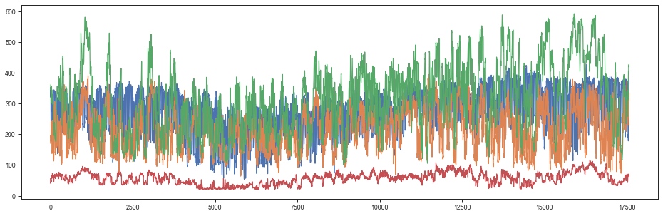

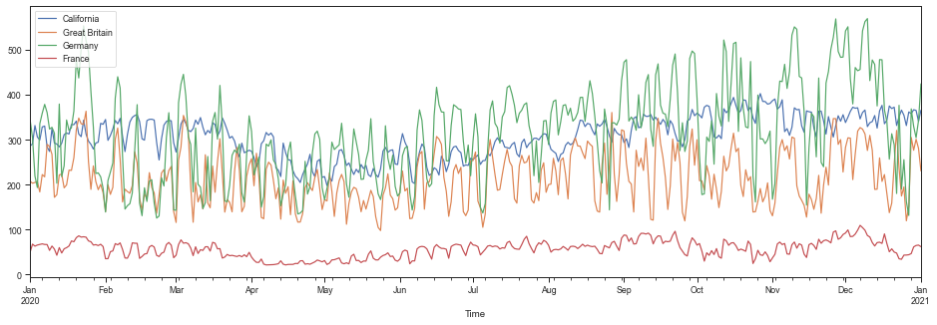

SNS plot of Population Density with carbon intensity
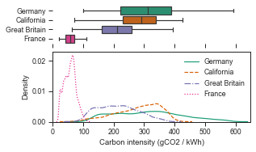

Weekly Analyse and Computing Carbon Intensity of different workdays and weekends
x["time"] = df.index.day_of_week * 24 * 60 + df.index.hour * 60 + index.minute
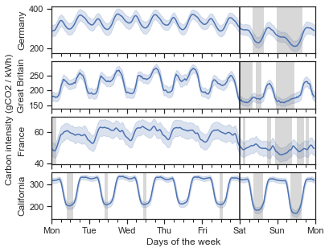
print(df.name)
print(workdays.mean().values)
print(weekend.mean().values)
print(f"{(1 - weekend.mean() / workdays.mean()).values[0]:.2%}")
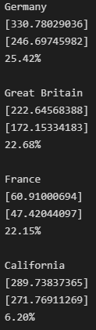
Evaluation.ipynb
It will show Graph Outputs by Computing on Carbon Intensity, Avoiding Carbon Emissions according to scheduling of Work days.

Plots Average Carbon Intensity in every country.
Taking 2h intervals
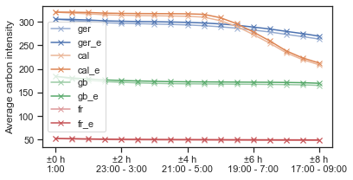
Percentage of Avoided Emissions in no shift.
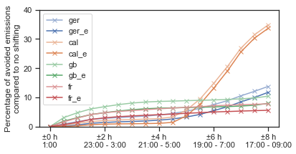

Percentage of Avoided emissions with Carbon Intensity in every country per flexibility window for scheduling.
Having Optimal and 5% Error
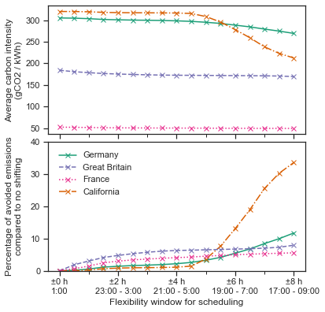

Dataset for Demand of Jobs relative to supply
cal_hist = [0.1, 0.1, 0.0, 0.0, 0.1, 0.1, 0.0, 0.1, 0.1, 0.1, 0.1, 0.1, 0.0, 0.5, 2.4, 11.4, 33.3, 89.8, 218.5, 0.0, 0.0, 0.0, 0.0, 0.0, 0.0, 0.0, 0.0, 0.0, 0.0, 0.0, 0.0, 0.0, 0.0, 0.0, 4.9, 0.5, 0.0, 0.2, 0.1, 0.1, 0.2, 0.2, 0.1, 0.3, 0.3, 0.1, 0.2, 0.0]
gb_hist = [20.1, 18.4, 13.8, 19.7, 20.1, 17.6, 20.2, 24.9, 24.9, 19.0, 13.0, 9.1, 8.4, 6.3, 6.3, 5.3, 8.4, 11.9, 21.9, 0.0, 0.0, 0.0, 0.0, 0.0, 0.0, 0.0, 0.0, 0.0, 0.0, 0.0, 0.0, 0.0, 0.0, 0.0, 7.1, 4.0, 1.1, 0.9, 0.9, 1.1, 2.0, 1.8, 3.1, 4.0, 5.0, 9.8, 14.4, 19.5]
ger_hist = [9.0, 13.3, 14.1, 14.9, 16.1, 14.5, 12.2, 10.2, 6.4, 3.5, 2.3, 2.3, 1.6, 2.2, 4.5, 8.4, 19.0, 43.4, 95.7, 0.0, 0.0, 0.0, 0.0, 0.0, 0.0, 0.0, 0.0, 0.0, 0.0, 0.0, 0.0, 0.0, 0.0, 0.0, 14.9, 6.1, 4.4, 2.2, 2.4, 2.1, 2.8, 2.8, 2.0, 2.8, 5.3, 6.2, 7.7, 8.7]
fr_hist = [10.7, 14.3, 19.5, 24.1, 24.8, 25.0, 24.7, 15.5, 12.2, 8.0, 6.3, 4.9, 5.8, 5.5, 5.1, 5.2, 8.3, 7.6, 10.0, 0.0, 0.0, 0.0, 0.0, 0.0, 0.0, 0.0, 0.0, 0.0, 0.0, 0.0, 0.0, 0.0, 0.0, 0.0, 10.5, 8.8, 10.9, 10.5, 12.7, 9.0, 8.5, 7.4, 6.2, 5.4, 7.2, 10.4, 9.0, 10.0]

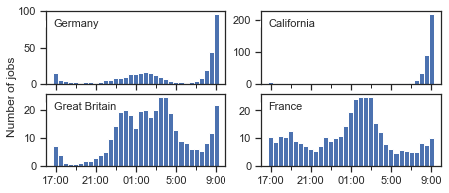

Head of 5 | active_jobs | ci | emissions
Time
2020-01-01 00:00:00 | 0.0 | 342.092256 | 0.0
2020-01-01 00:30:00 | 0.0 | 347.220539 | 0.0
2020-01-01 01:00:00 | 0.0 | 344.967632 | 0.0
2020-01-01 01:30:00 | 0.0 | 339.952418 | 0.0
2020-01-01 02:00:00 | 0.0 | 336.563101 | 0.0
Workday with 5% error
e_b = baseline["emissions"].sum() / 2 / 1000000
e_x = x["emissions"].sum() / 2 / 1000000
e_xi = xi["emissions"].sum() / 2 / 1000000
Non-interruptible: {1 - e_x/e_b:.2%}
Interruptible: {1 - e_xi/e_b:.2%}
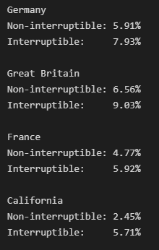
Continuous Integration on Emission Rate via Work Days. (-- Interrupting , : Non Interrupting)
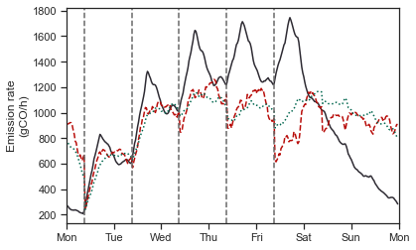
Emission Rate on Next Work Day , Semi Weekly in France
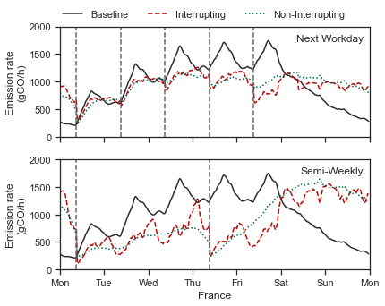

Carbon Emission Saved on Next Workday , Semi-Weekly in Germany,California,Great Britain,France (No Error)
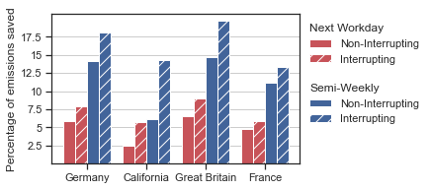
Carbon Emission Saved on Next WorkDay having 5% error 10% error.
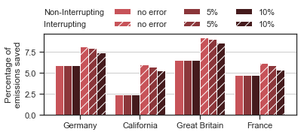

- References
References should be listed according to the order of each reference is cited in the text with the reference number in square brackets. The reference or multiple references should be cited as [1] [3] or [1,3] in the text wherever they are referred. The listing of journals or books after section of Summary and Future scope of work should include the name of the authors / full title of the article or book / name of journals or publisher / volume, Reference to book [1], paper from journal [2], and paper from proceeding [3] should be written in following format:

- Timoshenko, S. and Woinowsky-Krieger, S., Theory of Plates and Shells. Second Edition, McGraw-Hill, 1959.
- Belytschko, T., Lu, Y.Y. and Gu, L., “Element-free Galerkin Methods”. International Journal for Numerical Methods in Engineering; Vol. 37, 1994, pp. 229-256.
- Ma, H.T. and Kanok-Nukulchai, W., “On the application of assumed strain methods”, Proceedings of the second East Asia-Pacific Conference on Structural Engineering & Construction (EASEC-2), Chiang Mai, Thailand, January 11-13, 1989.
- Cough, R. W. and Penzien, J., “Response to a general dynamic loading”, Chapter 7, Dynamics of Structures, McGraw-Hill, Singapore, 1975.
(The titles of books, journals and conference proceedings should be in italic)

